

**USER MANUAL**

|  |  |  |
| --- | --- | --- |
|  |  |  |
| **COURSE** | **:** | WEB TECHNOLOGY |
| **COURSE CODE** | **:** | **ITT544** |
| **PROJECT** | **:** | **ICE CREAM SHOP** |

|  |  |
| --- | --- |
| **Name Of Lecturer** | Sir Mohd Ali |
| **Name:** | Muhammad Najmi Bin Noor Zairul |
| **Student ID:** | 2018659648 |
| **Name:** | Akalili Yusra Binti Sabari |
| **Student ID:** | 2018216424 |
| **Name:** | Hanania Aida binti Mohd Hilmi @ Mohd Nor |
| **Student ID:** | 2018216606 |
| **Name:** | Nurin Amirah Binti Abdul Rahman |
| **Student ID:** | 2018254468 |

INTRODUCTION

The Frostbite Ice Cream Shop is established in Jasin, Melaka since 2012 by a group of 4 entrepreneurs and businessmen. These 4 entrepreneurs and businessmen are seeking to accomplish our goal of owning Ice Cream Shop and manufacture our own ice cream invention so that people can be made with top caring and love.

What matters the most to us is our customer satisfaction. The Ice Cream Shop provides various of our own version ice creams with own unique and secret ingredients that are certified Halal and safe for consumption. The Frostbite Ice Cream Shop exceeds more than 8 branches across Peninsular Malaysia which are Melaka, Seremban, Cheras, Kuala Lumpur, Pulau Pinang, Perak, Selangor and our latest branch is at Perlis. Our goal is to have an establishment at every district in Malaysia including oversea such as Asean Countries.

We will always come up with new and unthought-of creation for our ice cream so that customers all around can experience new enjoyment for their taste buds to handle and we will persuade you to eat our ice cream more and more till Frostbite appears in you.

**USER MANUAL**

**Login Admin Page**

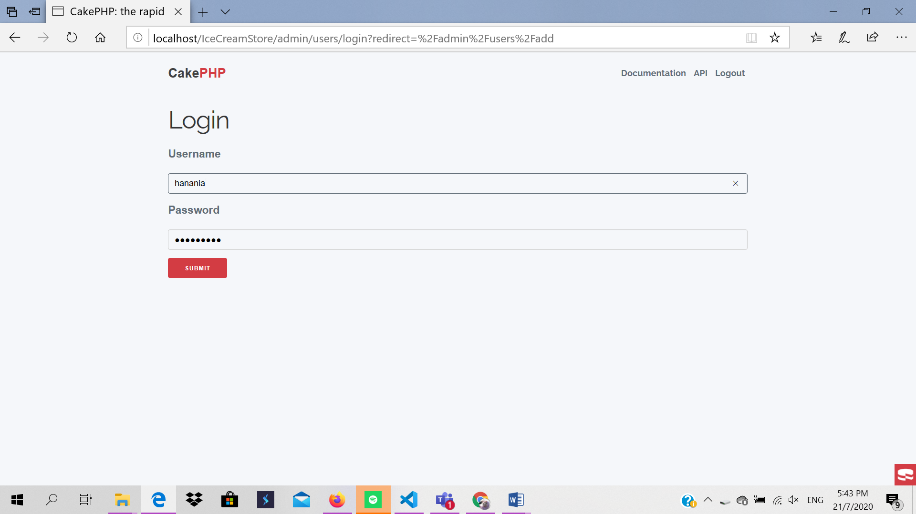

Description:

1. Admin insert username

2. Admin insert password

3. Click submit button

**Main Page**

After admin/user click submit button it will directly go to our(Ice Cream Website) main page.

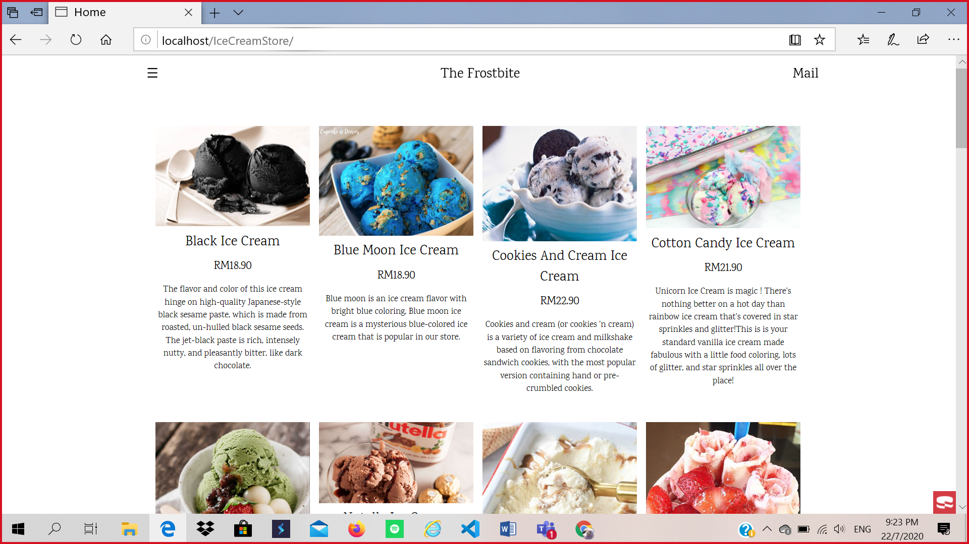

**Main page with sidebar**

User can choose any option on the sidebar of our main page.

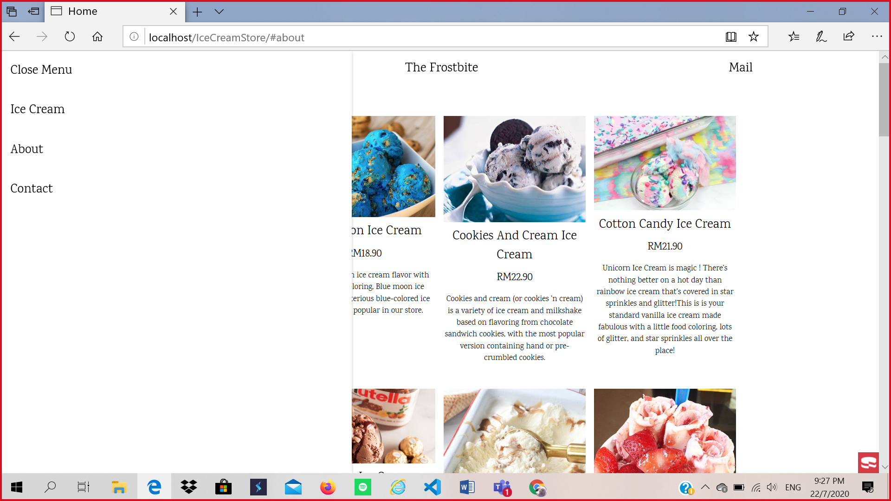

**Admin/Users Detail’s Page**

This is list of our user’s details.

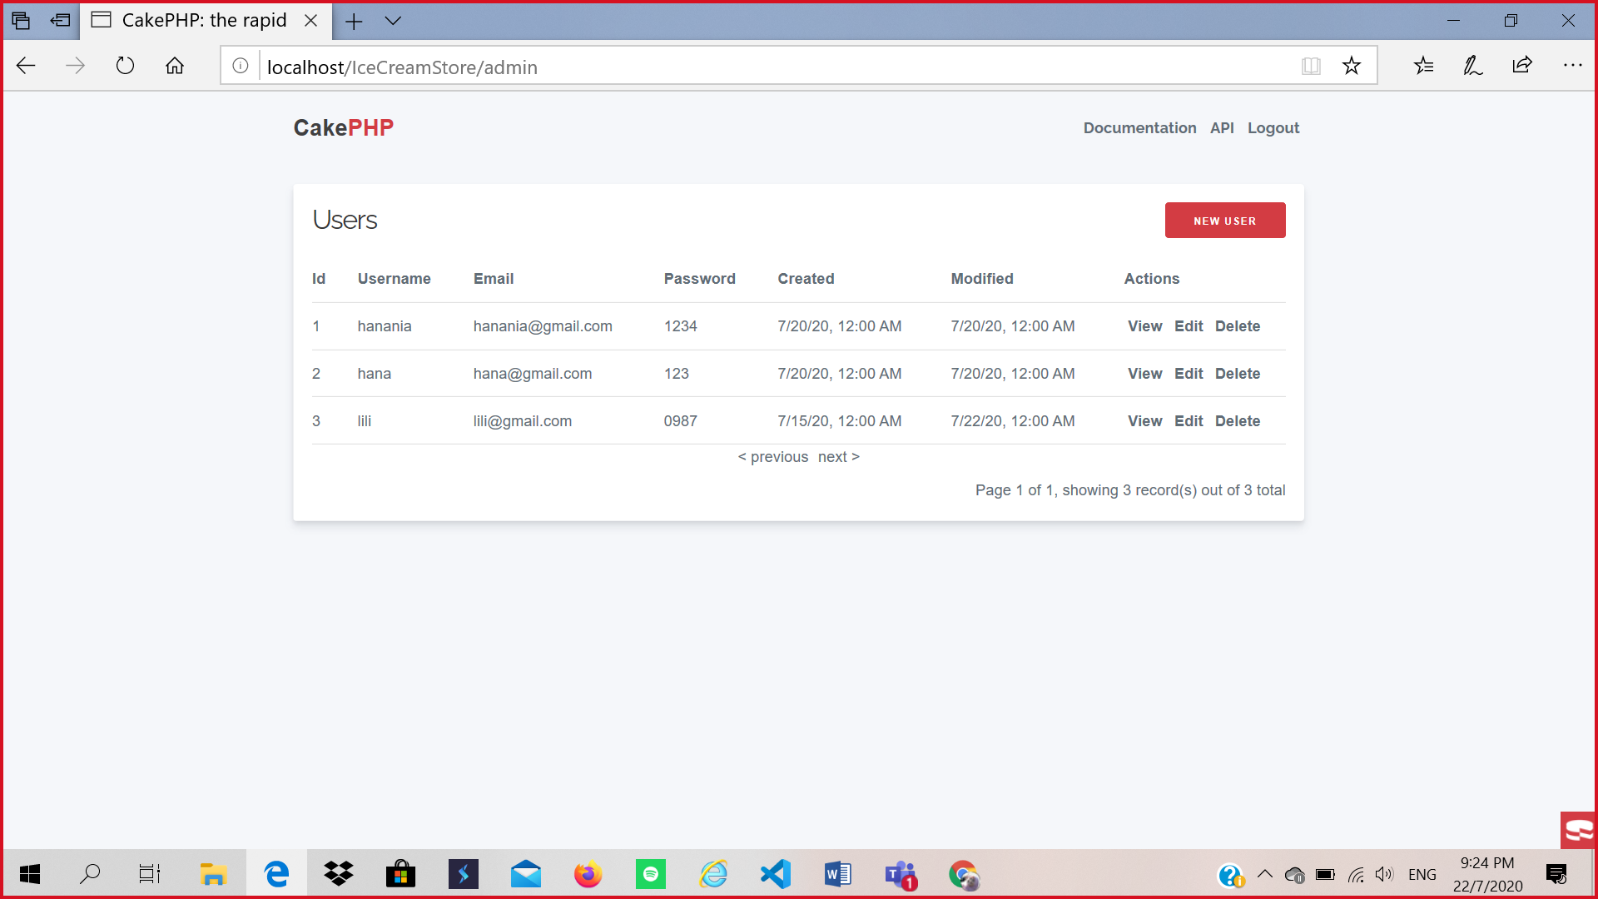

**Customer Detail’s Page**

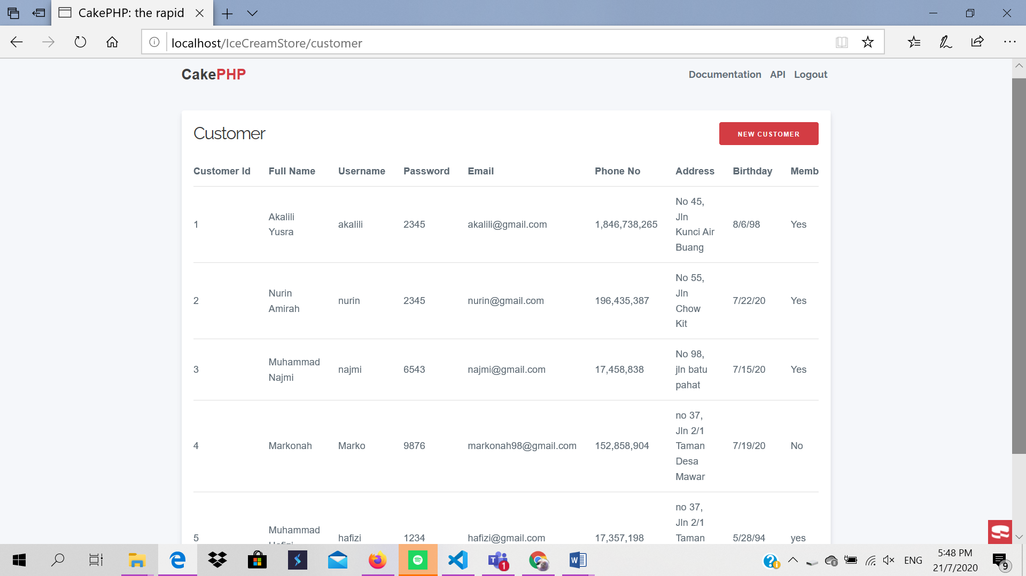

**Staff Detail’s Page**

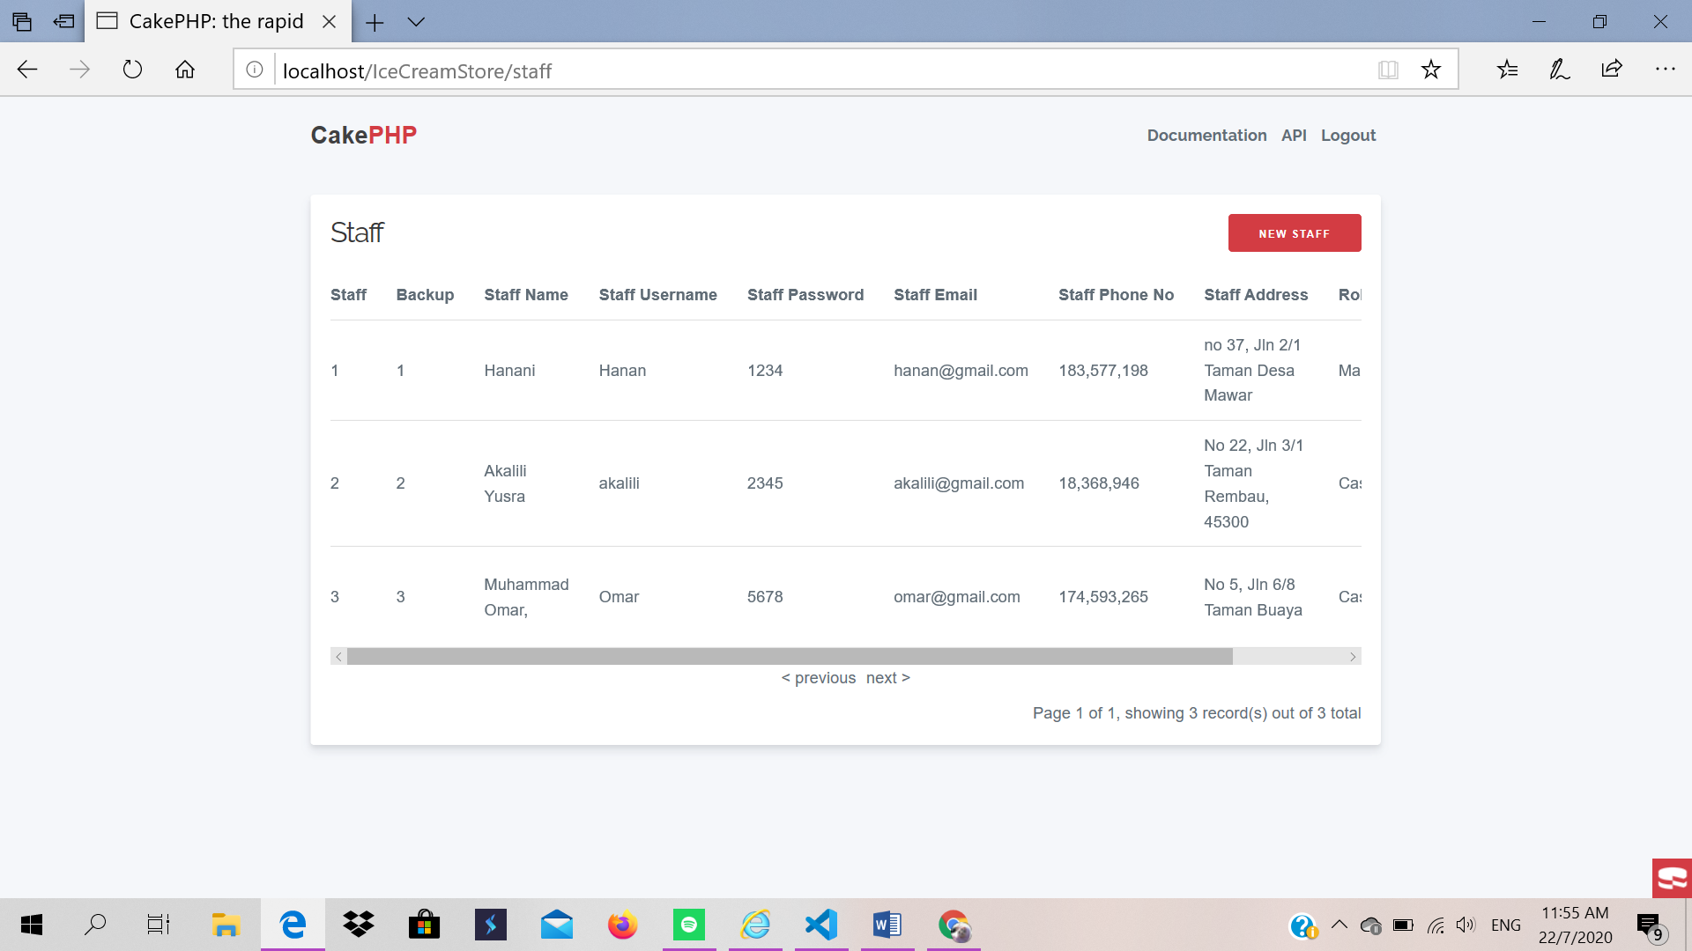

**Product Detail’s Page**

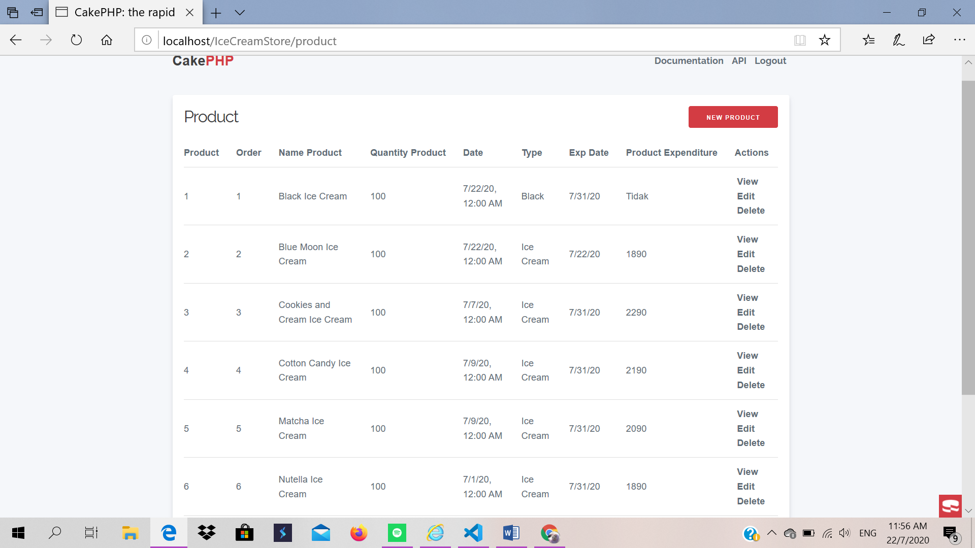

**Order Detail’s Page**

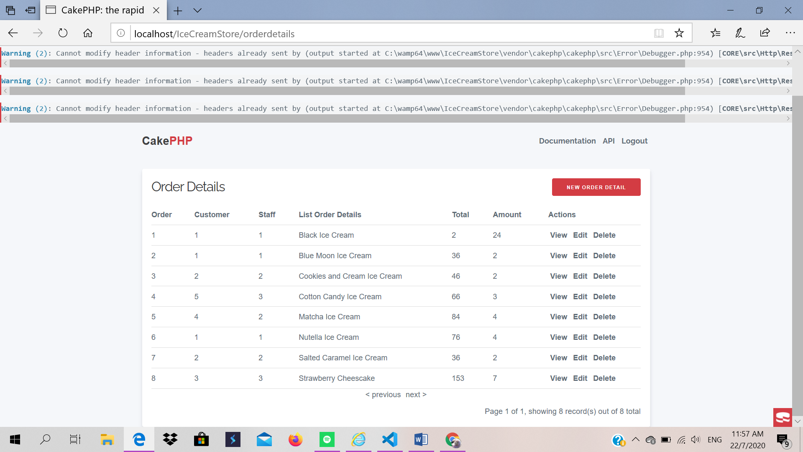

**Supply Detail’s Page**

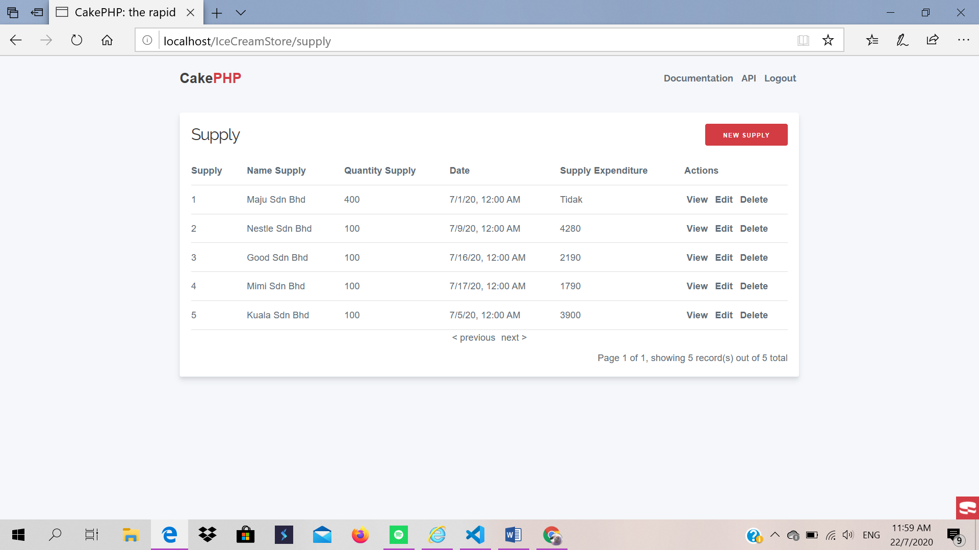

**Product_Supply Detail’s Page**

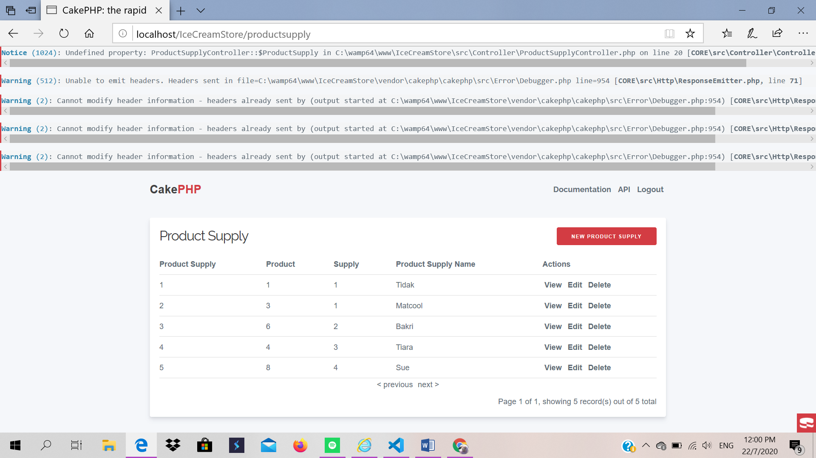

**View, Edit, Delete and logout**

Admin can view, edit and remove product details.

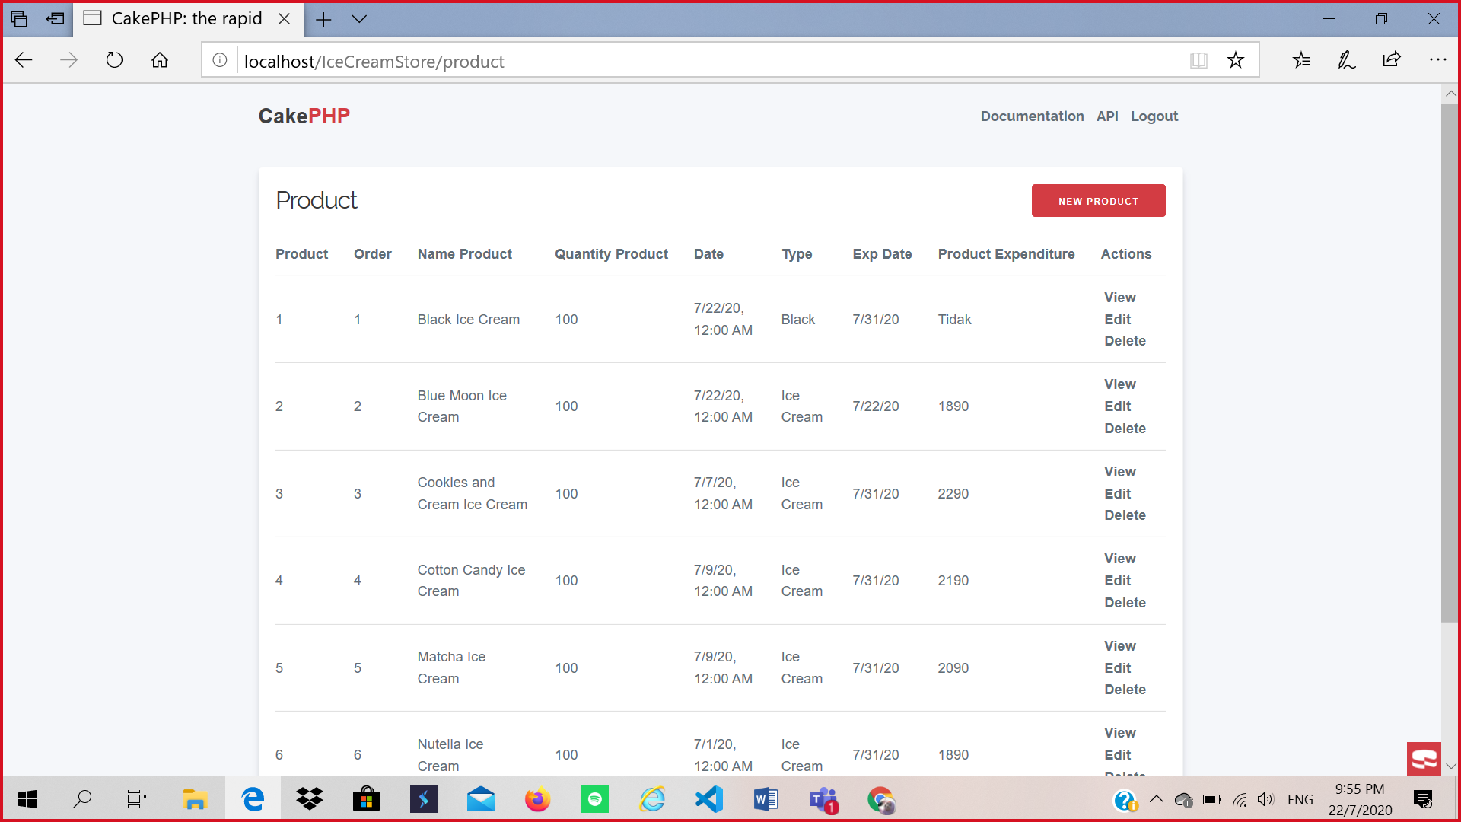

Description:

1 = Admin can view the list of product.

2 = Admin can edit product details.

3 = Admin can delete product.

4 = Admin can logout

4

3

2

1

**Map**

This is our location shop.

